CSE 483 Homework 2

Homework Objective: Provide students with the opportunity to work with WPF Observable Collections

Due Date: See Blackboard

Tic-Tac-Toe Game
- You are to develop a WPF Tic-Tac-Toe game using Observable Collections
- You can start with the project that we developed in class.
- The game should look something like the following picture, but does not have to be identical.
- You must have a text area that presents game status. For example:
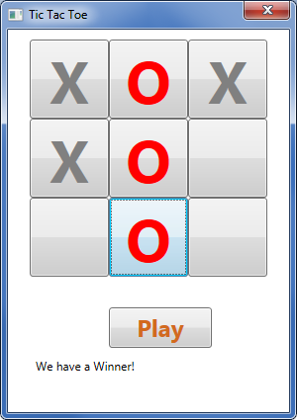
  - “We have a winner” when the game is won.
  - “We have a tie” if the game ends in a tie.
  - “Try again” if a user attempts to make their move in a grid space that has already been used.
  - For additional ideas, play the game that has been placed on the Blackboard.
- You must correctly identify when there is a winner.
- You must correctly identify when there is a tie.
- You must highlight the winning row.
- You must use Observable Collections
- You must have a separate Play button to Start or Restart the game.
- A sample solution has been provided on the Blackboard. This is for guidance only, and it is NOT intended that your solution would be identical.
- Have fun. Use different colors. Play around.

Format: Provide the information as follows:

- Zip project files.
- Upload the zip file via the web to the Blackboard.
- Please include your full name as part of the header in each source file.
- Please append _HW2 to the .zip file name (e.g. waclawski_HW2.zip).

